
NAME: KUNUTHURU DEEPTHI COURSE CODE: DSA0401
REG NO: 192472211 COURSE NAME: FUNDAMENTAL OF DATA SCIENCE

QUESTION 1
import pandas as pd
import matplotlib.pyplot as plt
import seaborn as sns
from google.colab import files
print("Upload student_data.csv")
uploaded = files.upload()
df = pd.read_csv("student_data.csv")
print("\n========== FIRST 5 RECORDS ==========")
print(df.head())
print("\n========== LAST 5 RECORDS ==========")
print(df.tail())
print("\n========== DATASET INFORMATION ==========")
df.info()
print("\nDataset Shape:")
print(df.shape)
print("\nColumn Names:")
print(df.columns)
print("\nMissing Values:")
print(df.isnull().sum())
print("\n========== MEAN ==========")
print(df[["Attendance","Study_Hours","Internal_Marks"]].mean())
print("\n========== MEDIAN ==========")
print(df[["Attendance","Study_Hours","Internal_Marks"]].median())
print("\n========== MODE ==========")
print(df[["Attendance","Study_Hours","Internal_Marks"]].mode())
print("\n========== VARIANCE ==========")
print(df[["Attendance","Study_Hours","Internal_Marks"]].var())
print("\n========== STANDARD DEVIATION ==========")
print(df[["Attendance","Study_Hours","Internal_Marks"]].std())
print("\n========== MINIMUM VALUES ==========")
print(df[["Attendance","Study_Hours","Internal_Marks"]].min())
print("\n========== MAXIMUM VALUES ==========")
print(df[["Attendance","Study_Hours","Internal_Marks"]].max())
print("\n========== SUMMARY STATISTICS ==========")
print(df.describe())
print("\n========== PASS / FAIL COUNT ==========")
print(df["Result"].value_counts())
print("\n========== AVERAGE VALUES BY RESULT ==========")
print(df.groupby("Result")[["Attendance","Study_Hours","Internal_Marks"]].mean())
df_corr = df.copy()
df_corr["Result"] = df_corr["Result"].map({"Fail":0,"Pass":1})

print("\n========== CORRELATION MATRIX ==========")
print(df_corr[["Attendance","Study_Hours","Internal_Marks","Result"]].corr())

# Style
sns.set_style("whitegrid")

# ------------------------------------------
# Pass / Fail Count Plot
# ------------------------------------------
plt.figure(figsize=(6,4))
sns.countplot(x="Result", data=df)
plt.title("Pass vs Fail Students")
plt.show()

# ------------------------------------------
# Attendance Distribution
# ------------------------------------------
plt.figure(figsize=(6,4))
sns.histplot(df["Attendance"], bins=10, kde=True)
plt.title("Attendance Distribution")
plt.xlabel("Attendance")
plt.show()

# ------------------------------------------
# Study Hours Distribution
# ------------------------------------------
plt.figure(figsize=(6,4))
sns.histplot(df["Study_Hours"], bins=6, kde=True)
plt.title("Study Hours Distribution")
plt.xlabel("Study Hours")
plt.show()

# ------------------------------------------
# Internal Marks Distribution
# ------------------------------------------
plt.figure(figsize=(6,4))
sns.histplot(df["Internal_Marks"], bins=10, kde=True)
plt.title("Internal Marks Distribution")
plt.xlabel("Internal Marks")
plt.show()

# ------------------------------------------
# Attendance vs Result
# ------------------------------------------
plt.figure(figsize=(6,4))
sns.boxplot(x="Result", y="Attendance", data=df)
plt.title("Attendance vs Result")
plt.show()

# ------------------------------------------
# Study Hours vs Result
# ------------------------------------------
plt.figure(figsize=(6,4))
sns.boxplot(x="Result", y="Study_Hours", data=df)
plt.title("Study Hours vs Result")
plt.show()

# ------------------------------------------
# Internal Marks vs Result
# ------------------------------------------
plt.figure(figsize=(6,4))
sns.boxplot(x="Result", y="Internal_Marks", data=df)
plt.title("Internal Marks vs Result")
plt.show()

# ------------------------------------------
# Attendance vs Internal Marks
# ------------------------------------------
plt.figure(figsize=(6,4))
sns.scatterplot(
data=df,
x="Attendance",
y="Internal_Marks",
hue="Result",
s=100
)
plt.title("Attendance vs Internal Marks")
plt.show()

# ------------------------------------------
# Study Hours vs Internal Marks
# ------------------------------------------
plt.figure(figsize=(6,4))
sns.scatterplot(
data=df,
x="Study_Hours",
y="Internal_Marks",
hue="Result",
s=100
)
plt.title("Study Hours vs Internal Marks")
plt.show()

# ------------------------------------------
# Pair Plot
# ------------------------------------------
sns.pairplot(df, hue="Result")
plt.show()

# ==========================================
# CONCLUSION
# ==========================================

print("\n====================================")
print("EDA CONCLUSION")
print("====================================")
print("1. Students with attendance above 75% mostly PASS.")
print("2. Students studying 4 to 6 hours mostly PASS.")
print("3. Students scoring above 35 internal marks mostly PASS.")
print("4. Students with low attendance and low study hours mostly FAIL.")
print("5. Internal Marks show the strongest positive relationship with the final result.")
print("6. Attendance and Study Hours are also positively correlated with student performance.")
print("7. No missing values were found in the dataset.")
print("====================================")
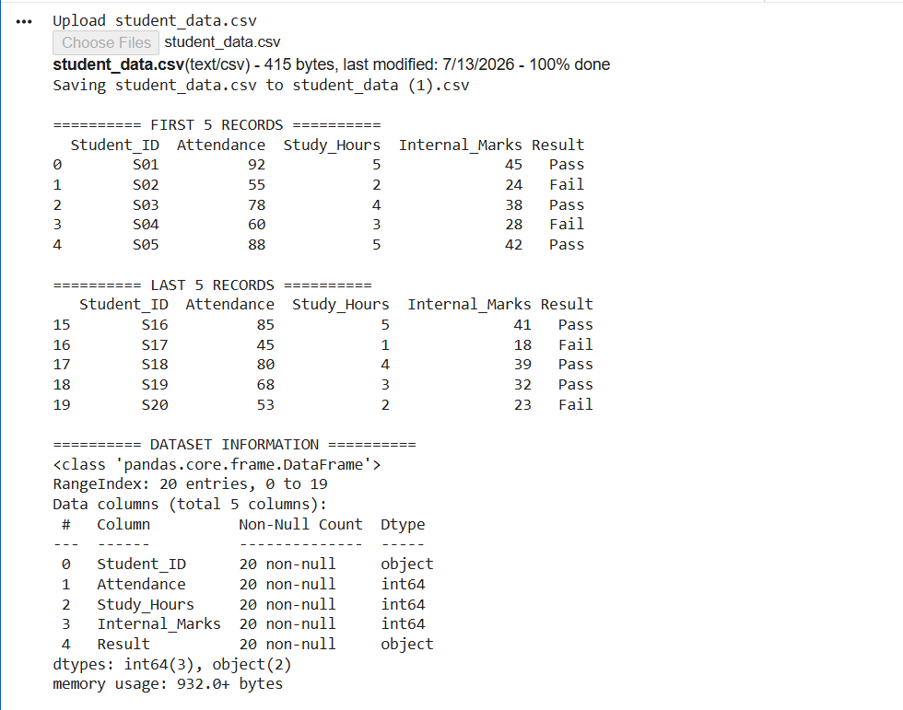
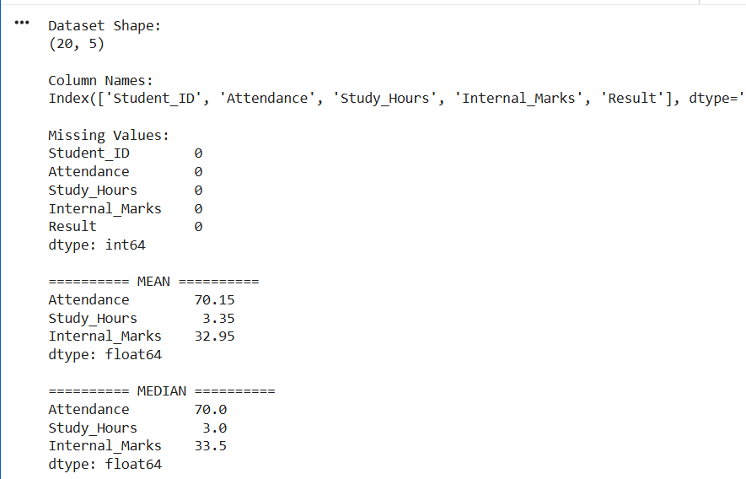

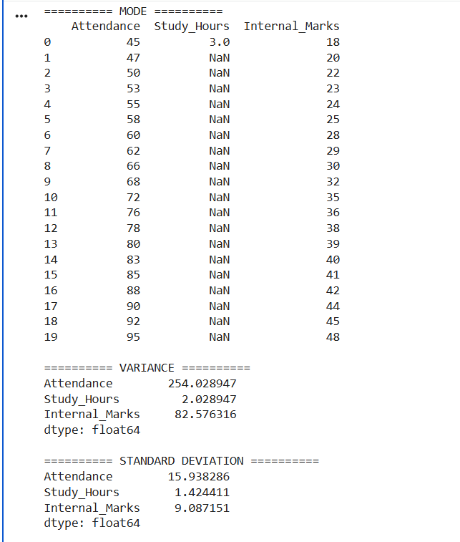
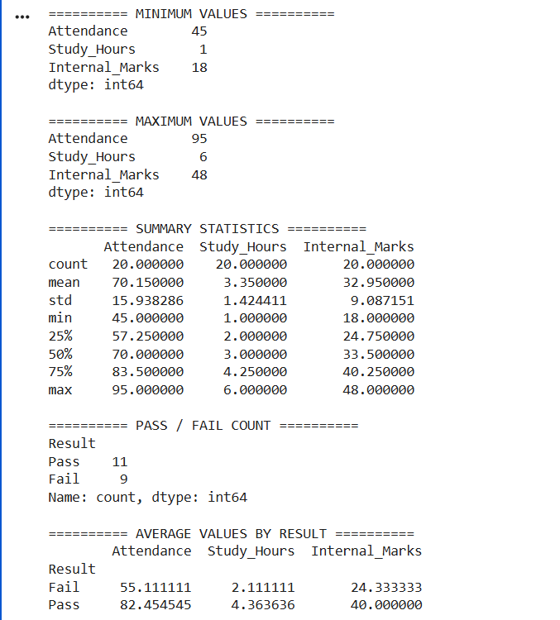
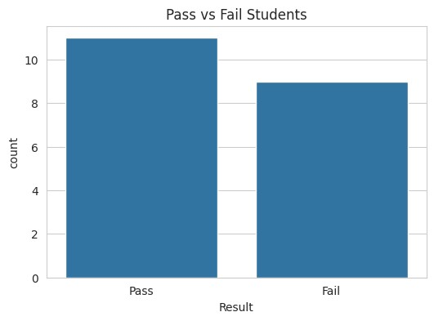
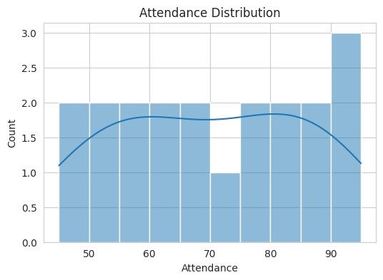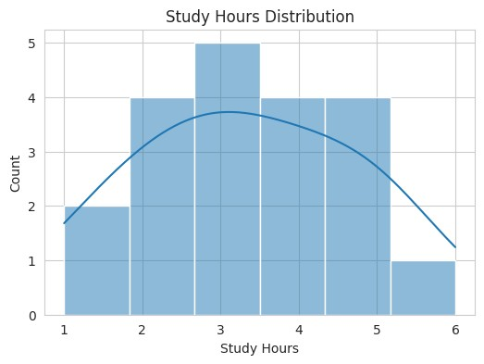
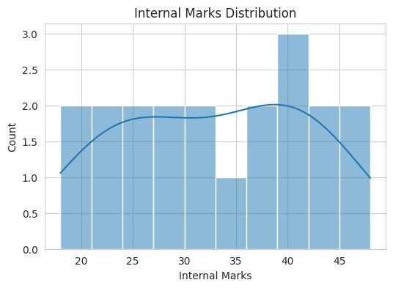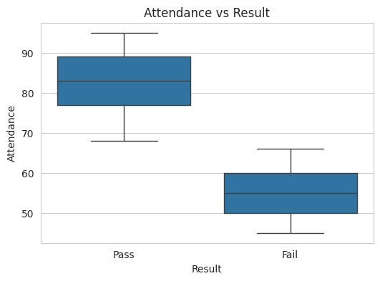
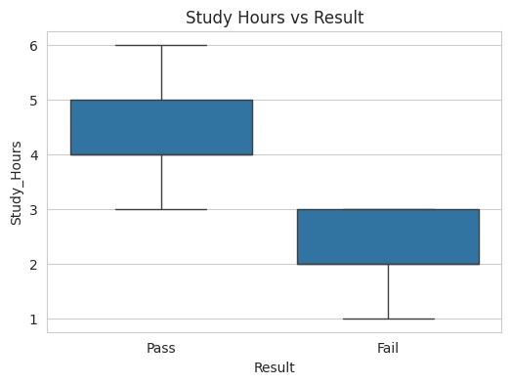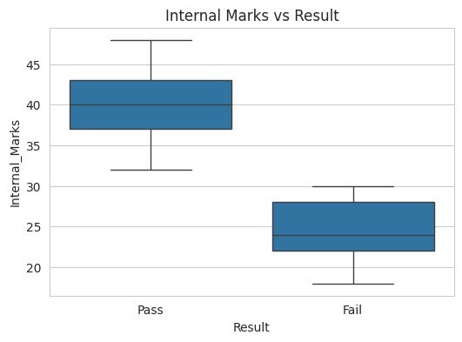
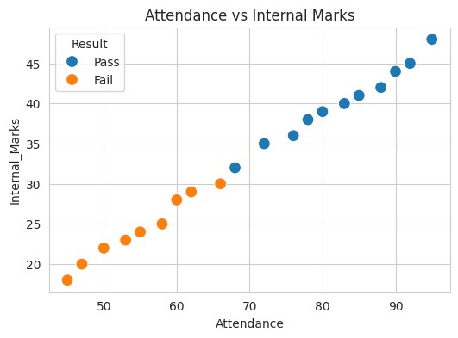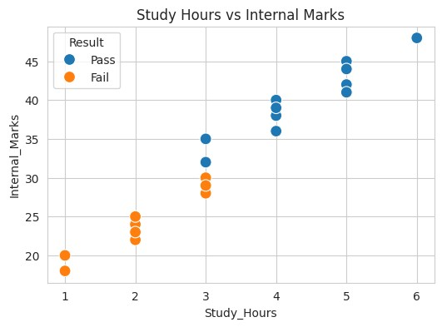

QUESTION 2
import pandas as pd
import numpy as np
import matplotlib.pyplot as plt
from google.colab import files
uploaded = files.upload()
filename = list(uploaded.keys())[0]
df = pd.read_csv(filename)
df.columns = df.columns.str.strip()
print("Column Names:")
print(df.columns.tolist())
disease_col = None
for col in df.columns:
if "disease" in col.lower():
disease_col = col
break
if disease_col is None:
print("\nDisease Status column not found!")
else:
print("\nFirst 5 Rows")
print(df.head())

print("\nLast 5 Rows")
print(df.tail())

print("\nDataset Info")
print(df.info())

print("\nShape")
print(df.shape)

print("\nMissing Values")
print(df.isnull().sum())

print("\nMean")
print(df.mean(numeric_only=True))

print("\nMedian")
print(df.median(numeric_only=True))

print("\nMode")
print(df.mode())

print("\nStandard Deviation")
print(df.std(numeric_only=True))

print("\nSummary Statistics")
print(df.describe())

# -----------------------------
# Disease Status Count
# -----------------------------
print("\nDisease Status Count")
print(df[disease_col].value_counts())

# -----------------------------
# Group Analysis
# -----------------------------
numeric_cols = df.select_dtypes(include=np.number).columns

print("\nAverage Values by Disease Status")
print(df.groupby(disease_col)[numeric_cols].mean())

# -----------------------------
# Correlation
# -----------------------------
print("\nCorrelation Matrix")
print(df[numeric_cols].corr())

# -----------------------------
# Histograms
# -----------------------------
df[numeric_cols].hist(figsize=(10,8))
plt.suptitle("Histogram of Numerical Features")
plt.show()

# -----------------------------
# Disease Status Bar Chart
# -----------------------------
plt.figure(figsize=(5,4))
df[disease_col].value_counts().plot(kind="bar")
plt.title("Disease Status Count")
plt.xlabel("Disease Status")
plt.ylabel("Count")
plt.show()

# -----------------------------
# Pie Chart
# -----------------------------
plt.figure(figsize=(5,5))
df[disease_col].value_counts().plot(kind="pie", autopct="%1.1f%%")
plt.ylabel("")
plt.title("Disease Status")
plt.show()

# -----------------------------
# Scatter Plot
# -----------------------------
if "Age" in df.columns and "Sugar_Level" in df.columns:
plt.figure(figsize=(6,4))
plt.scatter(df["Age"], df["Sugar_Level"])
plt.title("Age vs Sugar Level")
plt.xlabel("Age")
plt.ylabel("Sugar Level")
plt.show()

if "BMI" in df.columns and "BP" in df.columns:
plt.figure(figsize=(6,4))
plt.scatter(df["BMI"], df["BP"])
plt.title("BMI vs Blood Pressure")
plt.xlabel("BMI")
plt.ylabel("Blood Pressure")
plt.show()

# -----------------------------
# Boxplots
# -----------------------------
if "Sugar_Level" in df.columns:
plt.figure(figsize=(5,4))
plt.boxplot(df["Sugar_Level"])
plt.title("Sugar Level")
plt.show()

if "BMI" in df.columns:
plt.figure(figsize=(5,4))
plt.boxplot(df["BMI"])
plt.title("BMI")
plt.show()

print("\nEDA Completed Successfully!")

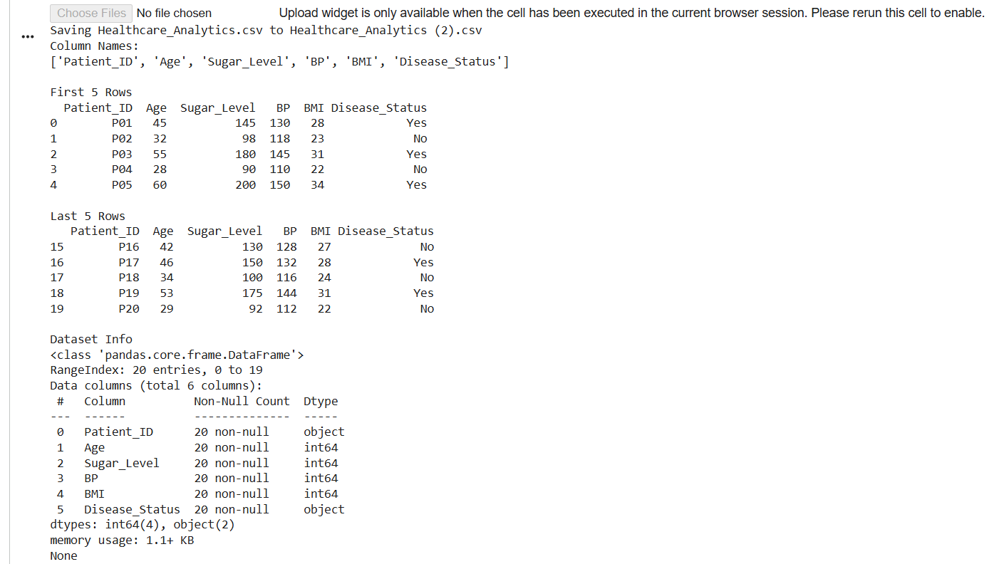

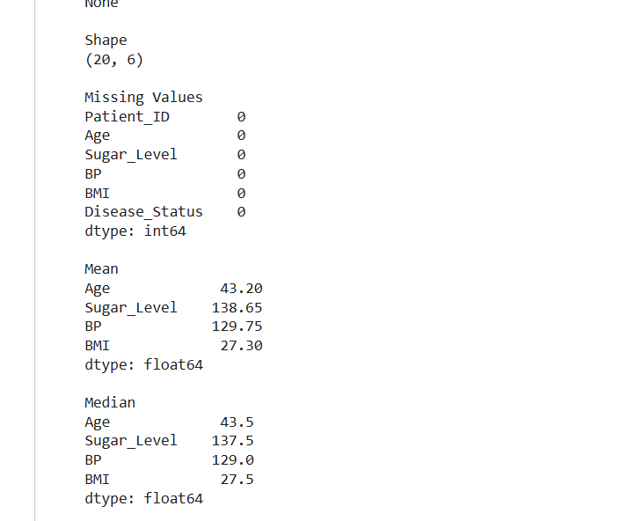
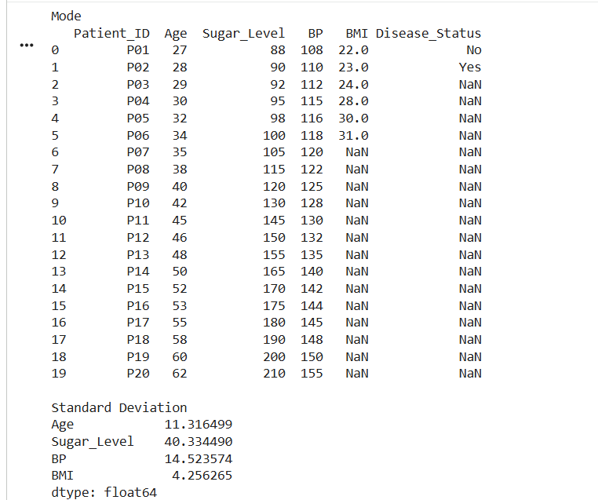

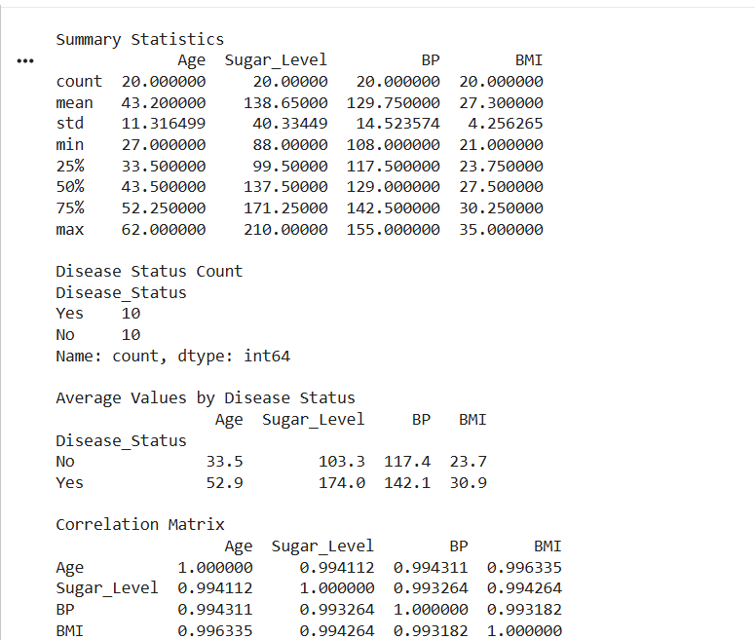
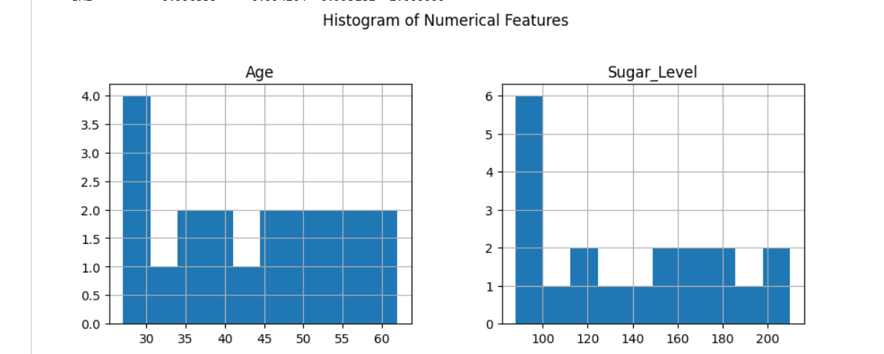
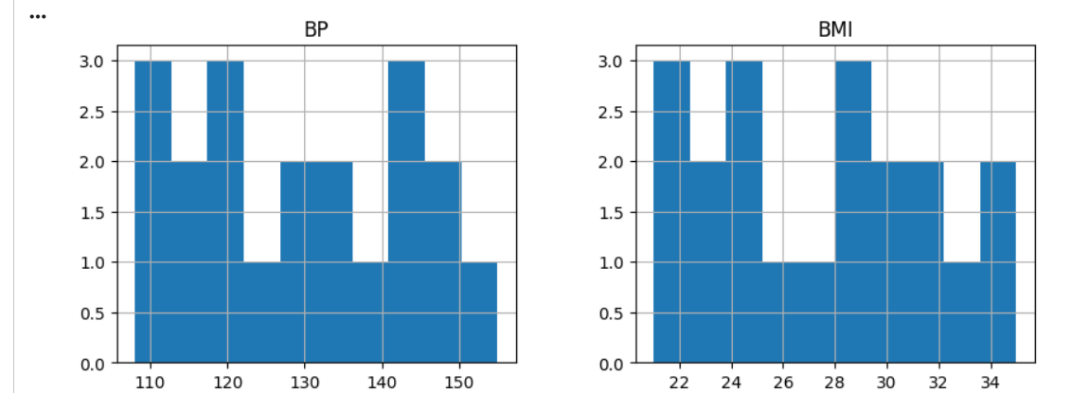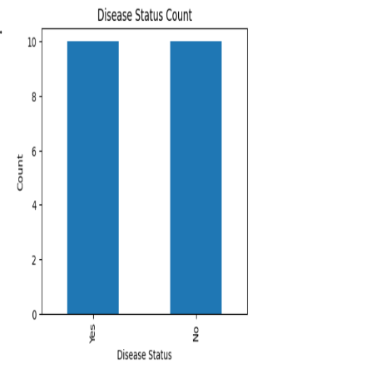
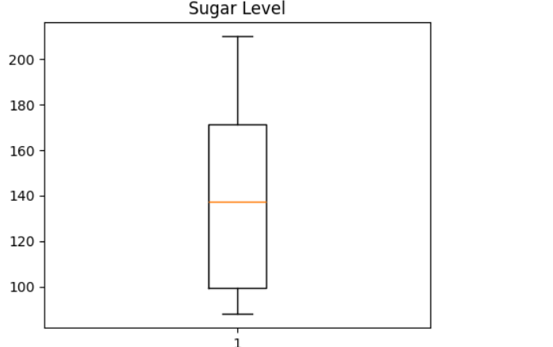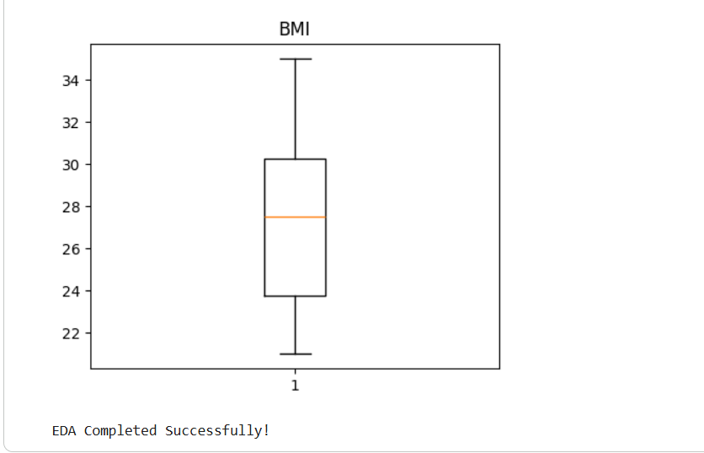

QUESTION 3
import pandas as pd
import numpy as np
import matplotlib.pyplot as plt
from google.colab import files
uploaded = files.upload()

# Read uploaded CSV file
filename = list(uploaded.keys())[0]
df = pd.read_csv(filename)

# -----------------------------
# Clean Column Names
# -----------------------------
df.columns = df.columns.str.strip()

print("Column Names:")
print(df.columns.tolist())

# -----------------------------
# Display Dataset
# -----------------------------
print("\nFirst 5 Rows")
print(df.head())

print("\nLast 5 Rows")
print(df.tail())

# -----------------------------
# Dataset Information
# -----------------------------
print("\nDataset Information")
df.info()

print("\nDataset Shape")
print(df.shape)

print("\nMissing Values")
print(df.isnull().sum())

# -----------------------------
# Statistical Analysis
# -----------------------------
print("\nMean")
print(df.mean(numeric_only=True))

print("\nMedian")
print(df.median(numeric_only=True))

print("\nMode")
print(df.mode())

print("\nStandard Deviation")
print(df.std(numeric_only=True))

print("\nSummary Statistics")
print(df.describe())

# -----------------------------
# Category Count
# -----------------------------
print("\nCategory Count")
print(df["Category"].value_counts())

# -----------------------------
# Average Values by Category
# -----------------------------
print("\nAverage Price, Quantity, Discount and Revenue")
print(df.groupby("Category")[["Price","Quantity_Sold","Discount","Revenue"]].mean())

# -----------------------------
# Correlation Matrix
# -----------------------------
print("\nCorrelation Matrix")
print(df[["Price","Quantity_Sold","Discount","Revenue"]].corr())

# -----------------------------
# Highest Revenue Product
# -----------------------------
print("\nHighest Revenue Product")
print(df.loc[df["Revenue"].idxmax()])

# -----------------------------
# Highest Quantity Sold
# -----------------------------
print("\nHighest Selling Product")
print(df.loc[df["Quantity_Sold"].idxmax()])

# ==========================================
# Data Visualization
# ==========================================

# Histograms
df[["Price","Quantity_Sold","Discount","Revenue"]].hist(figsize=(10,8))
plt.suptitle("Histogram of Numerical Features")
plt.show()

# Category Count
plt.figure(figsize=(6,4))
df["Category"].value_counts().plot(kind="bar")
plt.title("Products by Category")
plt.xlabel("Category")
plt.ylabel("Count")
plt.show()

# Revenue by Category
plt.figure(figsize=(6,4))
df.groupby("Category")["Revenue"].sum().plot(kind="bar")
plt.title("Total Revenue by Category")
plt.xlabel("Category")
plt.ylabel("Revenue")
plt.show()

# Pie Chart
plt.figure(figsize=(6,6))
df["Category"].value_counts().plot(kind="pie", autopct="%1.1f%%")
plt.title("Category Distribution")
plt.ylabel("")
plt.show()

# Scatter Plot
plt.figure(figsize=(6,4))
plt.scatter(df["Price"], df["Revenue"])
plt.title("Price vs Revenue")
plt.xlabel("Price")
plt.ylabel("Revenue")
plt.show()

# Scatter Plot
plt.figure(figsize=(6,4))
plt.scatter(df["Quantity_Sold"], df["Revenue"])
plt.title("Quantity Sold vs Revenue")
plt.xlabel("Quantity Sold")
plt.ylabel("Revenue")
plt.show()

# Line Plot
plt.figure(figsize=(8,4))
plt.plot(df["Revenue"], marker='o')
plt.title("Revenue of Products")
plt.xlabel("Product Index")
plt.ylabel("Revenue")
plt.show()

# Box Plot - Revenue
plt.figure(figsize=(5,4))
plt.boxplot(df["Revenue"])
plt.title("Revenue Box Plot")
plt.show()

# Box Plot - Price
plt.figure(figsize=(5,4))
plt.boxplot(df["Price"])
plt.title("Price Box Plot")
plt.show()

print("\nEDA Completed Successfully!")

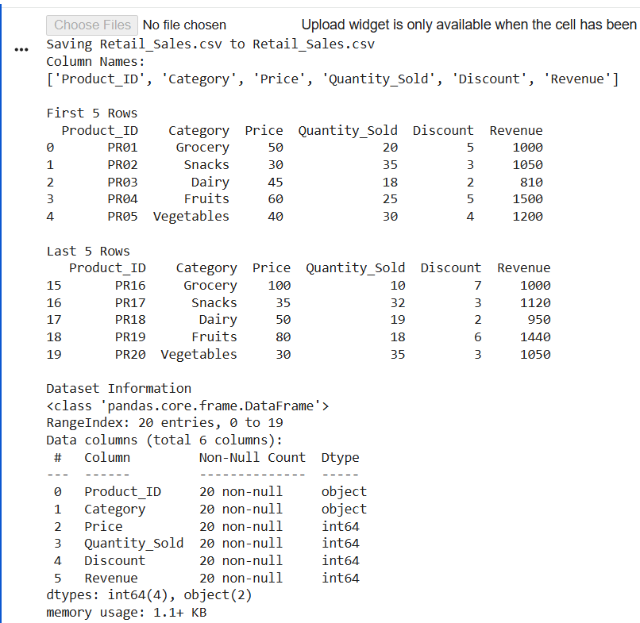

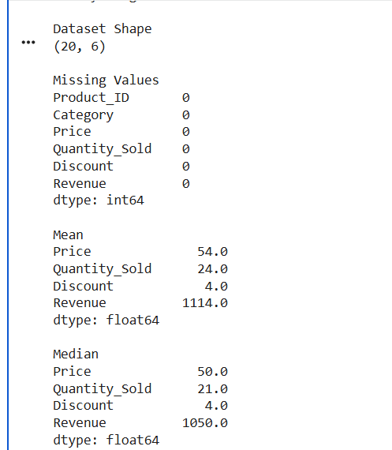
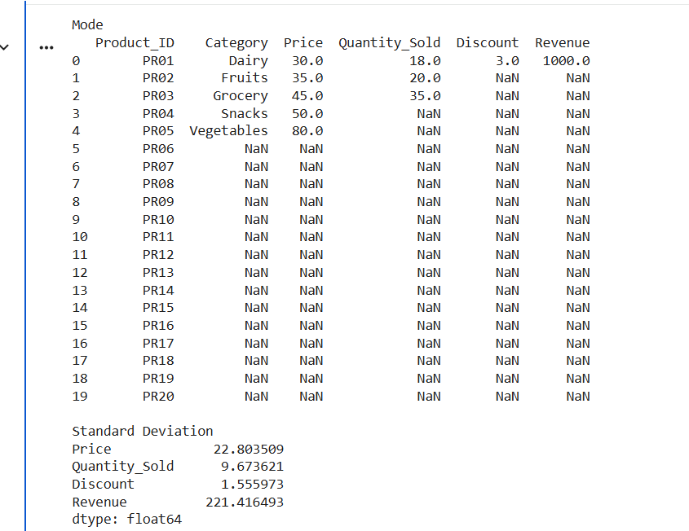
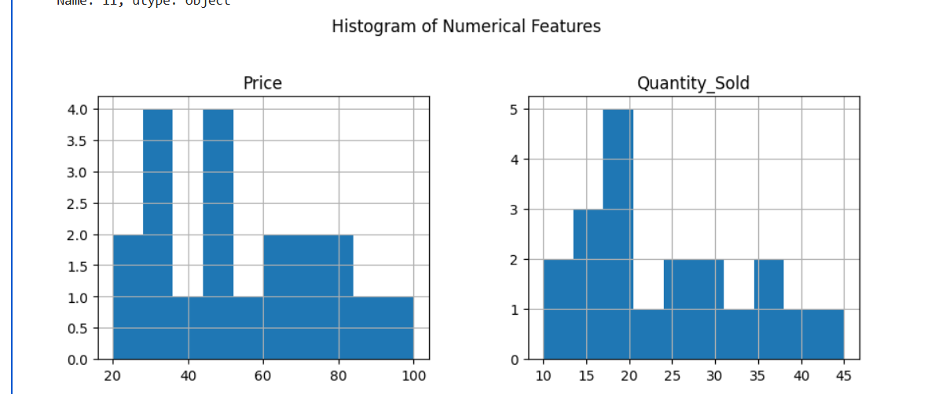
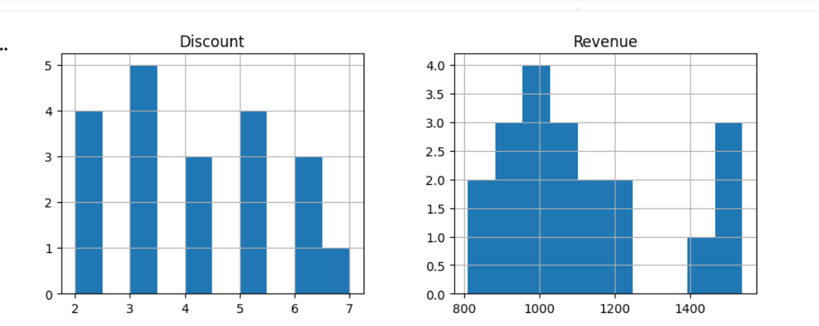
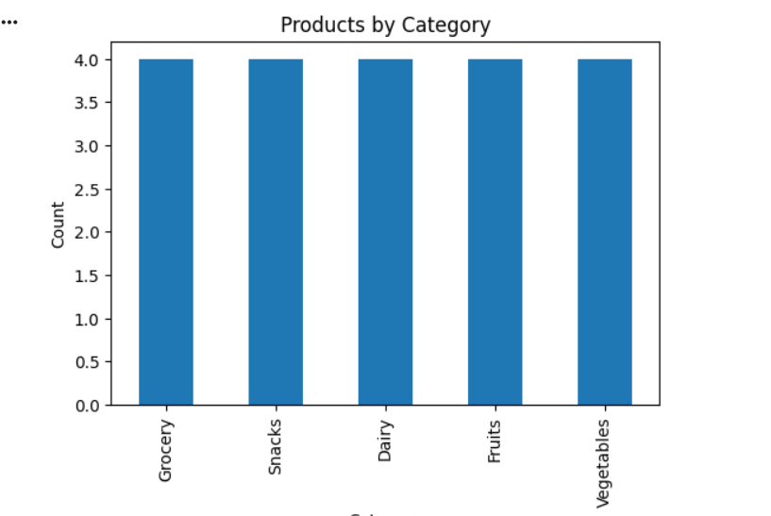
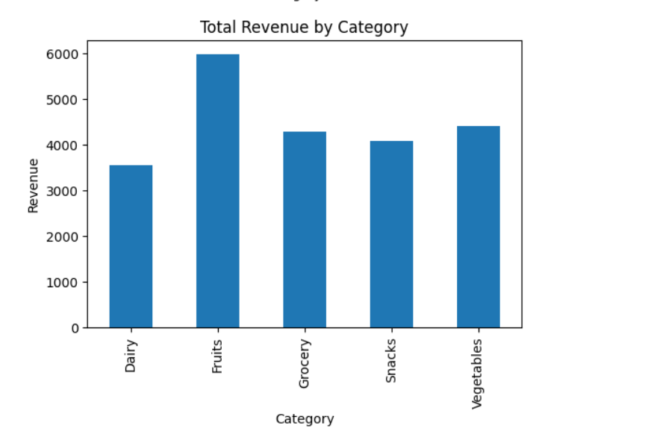

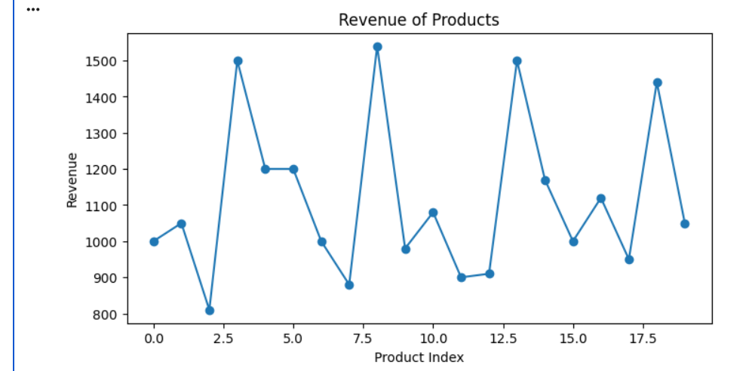
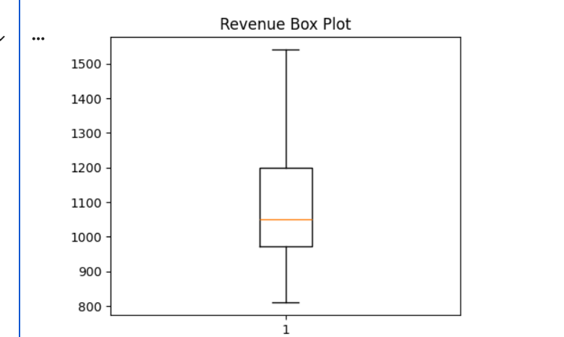
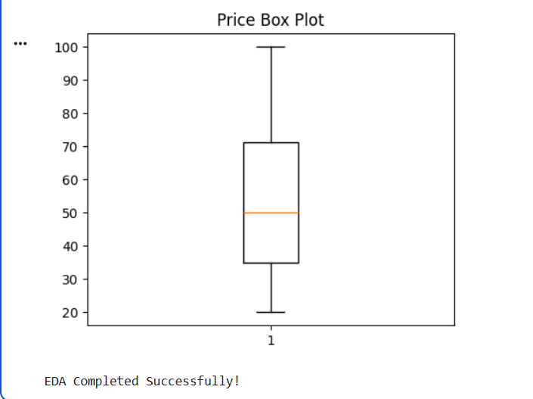

QUESTION 4

import pandas as pd
import numpy as np
import matplotlib.pyplot as plt
from google.colab import files
# -----------------------------
# Upload CSV File
# -----------------------------
uploaded = files.upload()
# Read uploaded CSV
filename = list(uploaded.keys())[0]
df = pd.read_csv(filename)
# -----------------------------
# Clean Column Names
# -----------------------------
df.columns = df.columns.str.strip()
print("Column Names:")
print(df.columns.tolist())
# -----------------------------
# Display Dataset
# -----------------------------
print("\nFirst 5 Rows")
print(df.head())

print("\nLast 5 Rows")
print(df.tail())
# -----------------------------
# Dataset Information
# -----------------------------
print("\nDataset Information")
df.info()

print("\nDataset Shape")
print(df.shape)

print("\nMissing Values")
print(df.isnull().sum())
# -----------------------------
# Statistical Analysis
# -----------------------------
print("\nMean")
print(df.mean(numeric_only=True))

print("\nMedian")
print(df.median(numeric_only=True))

print("\nMode")
print(df.mode())

print("\nStandard Deviation")
print(df.std(numeric_only=True))

print("\nSummary Statistics")
print(df.describe())
# -----------------------------
# Loan Status Count
# -----------------------------
print("\nLoan Status Count")
print(df["Loan_Status"].value_counts())
# -----------------------------
# Employment Type Count
# -----------------------------
print("\nEmployment Type Count")
print(df["Employment_Type"].value_counts())
# -----------------------------
# Group Analysis
# -----------------------------
print("\nAverage Income, Credit Score and Loan Amount by Loan Status")
print(df.groupby("Loan_Status")[["Income","Credit_Score","Loan_Amount"]].mean())
# -----------------------------
# Correlation Matrix
# -----------------------------
print("\nCorrelation Matrix")
print(df[["Income","Credit_Score","Loan_Amount"]].corr())
# -----------------------------
# Highest Income Customer
# -----------------------------
print("\nHighest Income Customer")
print(df.loc[df["Income"].idxmax()])
# -----------------------------
# Highest Credit Score
# -----------------------------
print("\nHighest Credit Score")
print(df.loc[df["Credit_Score"].idxmax()])
# ==========================================
# Data Visualization
# ==========================================
# Histograms
df[["Income","Credit_Score","Loan_Amount"]].hist(figsize=(10,8))
plt.suptitle("Histogram of Numerical Features")
plt.show()
# Loan Status Bar Chart
plt.figure(figsize=(5,4))
df["Loan_Status"].value_counts().plot(kind="bar")
plt.title("Loan Approval Status")
plt.xlabel("Loan Status")
plt.ylabel("Count")
plt.show()
# Employment Type Bar Chart
plt.figure(figsize=(6,4))
df["Employment_Type"].value_counts().plot(kind="bar")
plt.title("Employment Type")
plt.xlabel("Employment Type")
plt.ylabel("Count")
plt.show()
# Pie Chart
plt.figure(figsize=(5,5))
df["Loan_Status"].value_counts().plot(kind="pie", autopct="%1.1f%%")
plt.title("Loan Approval Percentage")
plt.ylabel("")
plt.show()
# Scatter Plot
plt.figure(figsize=(6,4))
plt.scatter(df["Income"], df["Loan_Amount"])
plt.title("Income vs Loan Amount")
plt.xlabel("Income")
plt.ylabel("Loan Amount")
plt.show()
# Scatter Plot
plt.figure(figsize=(6,4))
plt.scatter(df["Credit_Score"], df["Loan_Amount"])
plt.title("Credit Score vs Loan Amount")
plt.xlabel("Credit Score")
plt.ylabel("Loan Amount")
plt.show()

# Line Plot
plt.figure(figsize=(8,4))
plt.plot(df["Income"], marker='o', label="Income")
plt.plot(df["Credit_Score"], marker='s', label="Credit Score")
plt.title("Income and Credit Score")
plt.legend()
plt.show()

# Box Plot - Income
plt.figure(figsize=(5,4))
plt.boxplot(df["Income"])
plt.title("Income Box Plot")
plt.show()

# Box Plot - Credit Score
plt.figure(figsize=(5,4))
plt.boxplot(df["Credit_Score"])
plt.title("Credit Score Box Plot")
plt.show()

print("\nEDA Completed Successfully!")
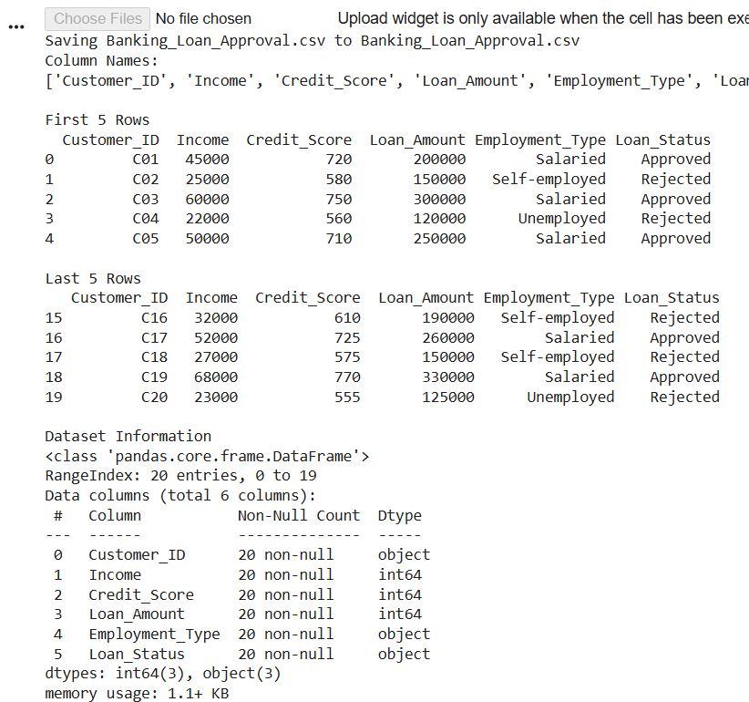

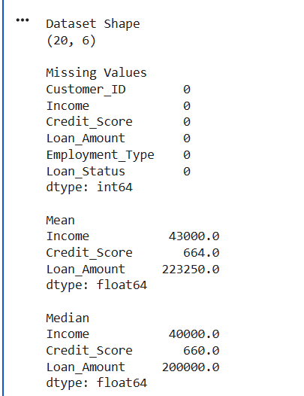
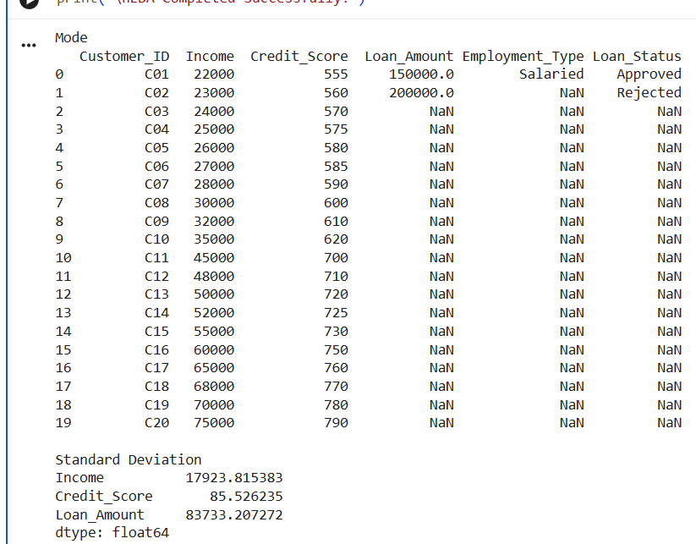

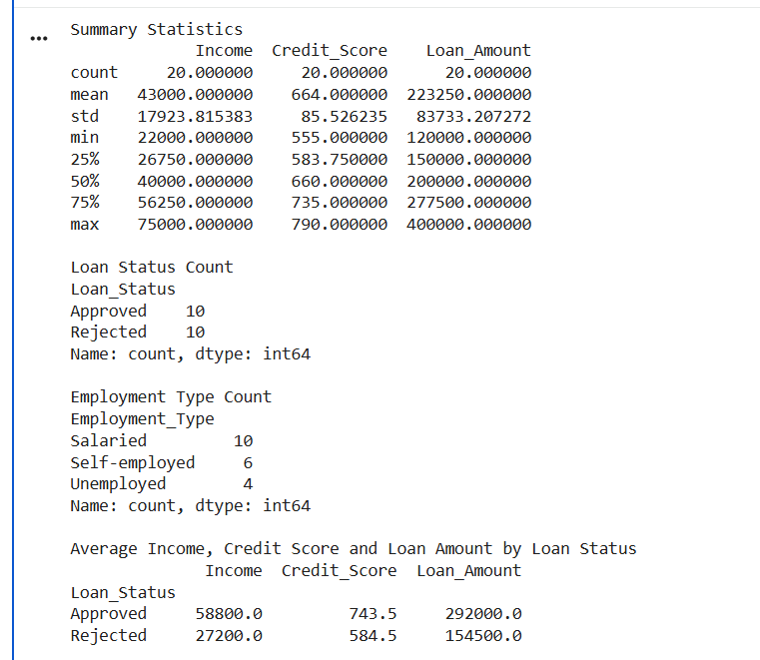
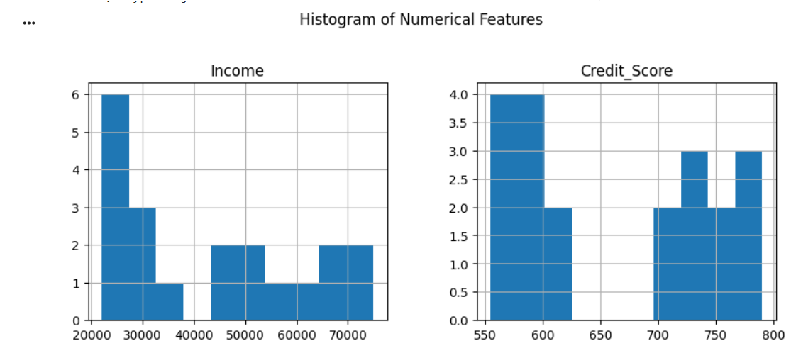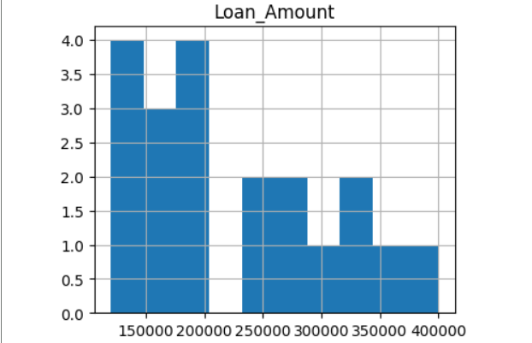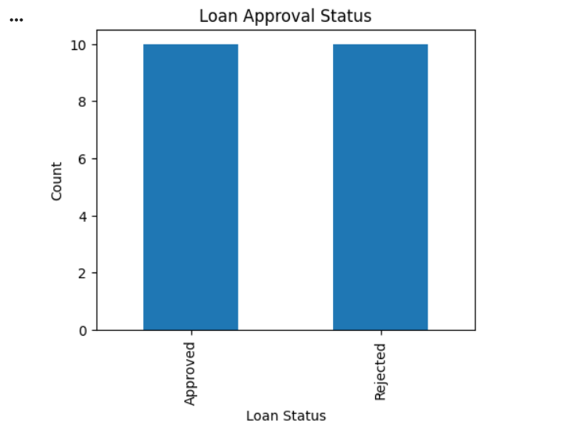
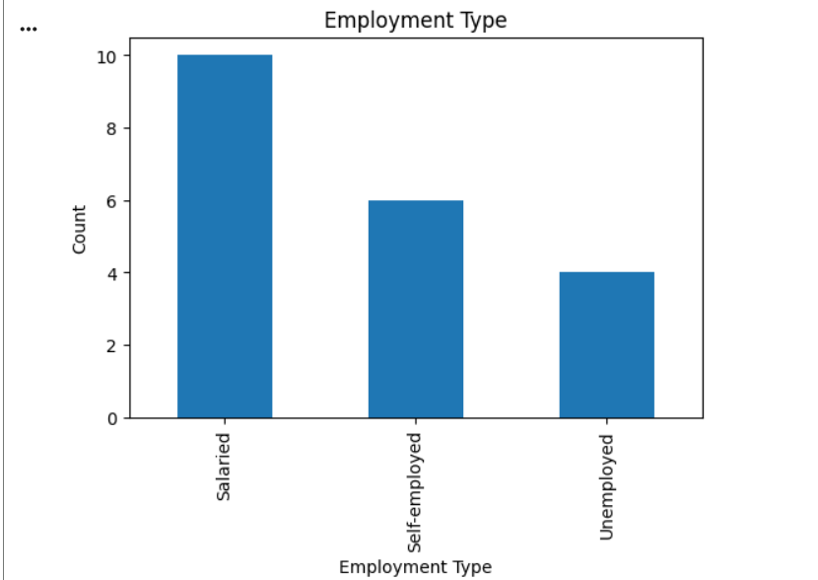
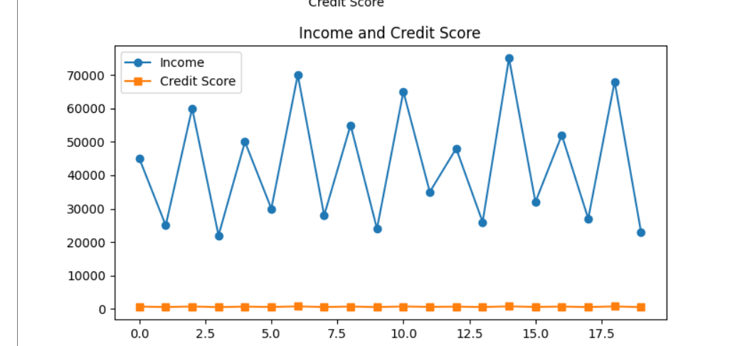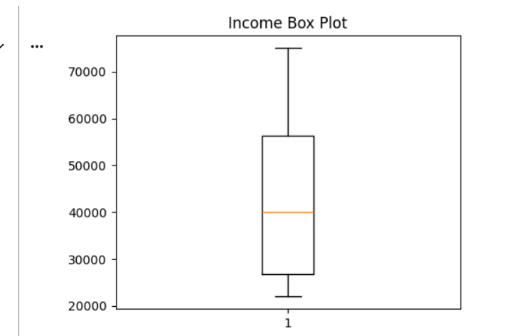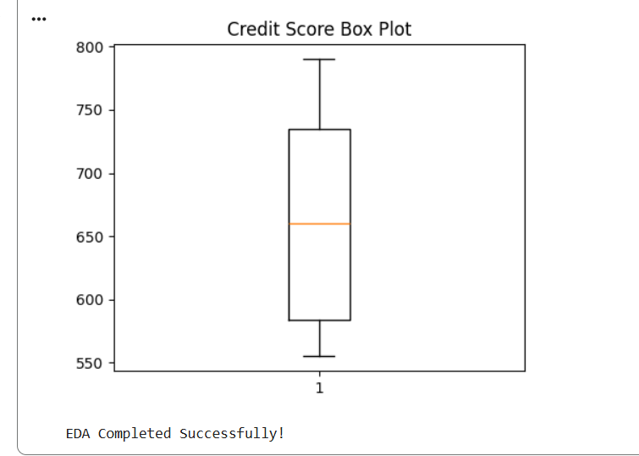

QUESTION 5
import pandas as pd
import numpy as np
import matplotlib.pyplot as plt
from google.colab import files
# -----------------------------
# Upload CSV File
# -----------------------------
uploaded = files.upload()
# Read uploaded CSV
filename = list(uploaded.keys())[0]
df = pd.read_csv(filename)
# -----------------------------
# Clean Column Names
# -----------------------------
df.columns = df.columns.str.strip()
print("Column Names:")
print(df.columns.tolist())
# -----------------------------
# Display Dataset
# -----------------------------
print("\nFirst 5 Rows")
print(df.head())

print("\nLast 5 Rows")
print(df.tail())
# -----------------------------
# Dataset Information
# -----------------------------
print("\nDataset Information")
df.info()

print("\nDataset Shape")
print(df.shape)

print("\nMissing Values")
print(df.isnull().sum())
# -----------------------------
# Statistical Analysis
# -----------------------------
print("\nMean")
print(df.mean(numeric_only=True))

print("\nMedian")
print(df.median(numeric_only=True))

print("\nMode")
print(df.mode())

print("\nStandard Deviation")
print(df.std(numeric_only=True))

print("\nSummary Statistics")
print(df.describe())
# -----------------------------
# Soil Type Count
# -----------------------------
print("\nSoil Type Count")
print(df["Soil_Type"].value_counts())
# -----------------------------
# Average Values by Soil Type
# -----------------------------
print("\nAverage Rainfall, Temperature, Fertilizer and Crop Yield")
print(df.groupby("Soil_Type")[["Rainfall_mm","Temperature","Fertilizer_kg","Crop_Yield_kg"]].mean())
# -----------------------------
# Correlation Matrix
# -----------------------------
print("\nCorrelation Matrix")
print(df[["Rainfall_mm","Temperature","Fertilizer_kg","Crop_Yield_kg"]].corr())
# -----------------------------
# Highest Crop Yield
# -----------------------------
print("\nHighest Crop Yield")
print(df.loc[df["Crop_Yield_kg"].idxmax()])
# -----------------------------
# Highest Rainfall
# -----------------------------
print("\nHighest Rainfall")
print(df.loc[df["Rainfall_mm"].idxmax()])
# ==========================================
# Data Visualization
# ==========================================
# Histograms
df[["Rainfall_mm","Temperature","Fertilizer_kg","Crop_Yield_kg"]].hist(figsize=(10,8))
plt.suptitle("Histogram of Numerical Features")
plt.show()

# Soil Type Count
plt.figure(figsize=(6,4))
df["Soil_Type"].value_counts().plot(kind="bar")
plt.title("Soil Type Distribution")
plt.xlabel("Soil Type")
plt.ylabel("Count")
plt.show()

# Average Crop Yield by Soil Type
plt.figure(figsize=(6,4))
df.groupby("Soil_Type")["Crop_Yield_kg"].mean().plot(kind="bar")
plt.title("Average Crop Yield by Soil Type")
plt.xlabel("Soil Type")
plt.ylabel("Crop Yield (kg)")
plt.show()

# Pie Chart
plt.figure(figsize=(6,6))
df["Soil_Type"].value_counts().plot(kind="pie", autopct="%1.1f%%")
plt.title("Soil Type Percentage")
plt.ylabel("")
plt.show()

# Scatter Plot
plt.figure(figsize=(6,4))
plt.scatter(df["Rainfall_mm"], df["Crop_Yield_kg"])
plt.title("Rainfall vs Crop Yield")
plt.xlabel("Rainfall (mm)")
plt.ylabel("Crop Yield (kg)")
plt.show()

# Scatter Plot
plt.figure(figsize=(6,4))
plt.scatter(df["Fertilizer_kg"], df["Crop_Yield_kg"])
plt.title("Fertilizer vs Crop Yield")
plt.xlabel("Fertilizer (kg)")
plt.ylabel("Crop Yield (kg)")
plt.show()

# Line Plot
plt.figure(figsize=(8,4))
plt.plot(df["Crop_Yield_kg"], marker='o')
plt.title("Crop Yield")
plt.xlabel("Farm Index")
plt.ylabel("Crop Yield (kg)")
plt.show()

# Box Plot - Rainfall
plt.figure(figsize=(5,4))
plt.boxplot(df["Rainfall_mm"])
plt.title("Rainfall Box Plot")
plt.show()

# Box Plot - Crop Yield
plt.figure(figsize=(5,4))
plt.boxplot(df["Crop_Yield_kg"])
plt.title("Crop Yield Box Plot")
plt.show()

print("\nEDA Completed Successfully!")

